Nexus Health Group New patient registration form
To register with Nexus Health Group, you must live within our catchment area. Please use the map below to see if your residential address is inside our practice boundary. Unfortuantely if you are not within our catchment area, we will not be able to register you at this time.
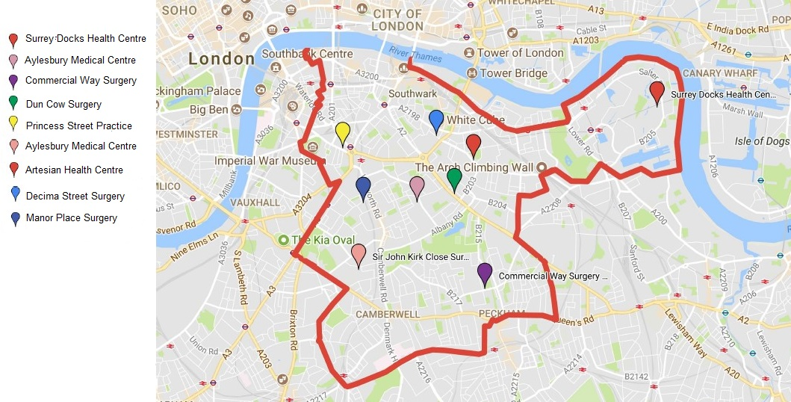

Complete one form per person. All information is kept strictly confidential. If you are only wishing to register a child today, please see the child registration section at the end of this form.

Please email your completed form to: nexus.recordsmanagement@nhs.net

Please check the box of the Nexus practice you would like to register with:
Artesian Health Centre | ☐
Aylesbury Medical Centre | ☐
Commercial Way Surgery | ☐
Decima Street Surgery | ☐
Dun Cow Surgery | ☐
Manor Place Surgery | ☐
Princess Street Practice | ☐
Sir John Kirk Close Surgery | ☐
Surrey Docks Health Centre | ☐

- Your personal details:
1.1 | Title | Mrs ☐ Ms ☐ Miss ☐ Mr ☐ Mx ☐ Dr ☐  Other ☐
1.2 | Last name
1.3 | First name(s)
1.4 | Previous last name(s)
1.5 | NHS number
1.6 | Date of birth
1.7 | Sex at birth | Female ☐ Male ☐
1.8 | Gender | Female ☐ Male ☐ Transgender ☐  Non-binary ☐ Intersex ☐ Prefer not to say ☐
1.9 | Ethnicity | White British ☐ White Irish ☐ Black Caribbean☐  Black African ☐ Black Caribbean and White ☐ Black African and White ☐ Indian ☐  Pakistani ☐ Bangladeshi ☐ Other ethnic group ☐ I do not wish to say ☐
1.10 | Religion
1.11 | Were you born in the United Kingdom? | Yes ☐ No ☐
 | If no, please state your country of birth and date of UK entry.

- Language support:

2.1 | What is your mail spoken language?
2.2 | Do you need an interpretor?
2.3 | Do you use any of the following? | Sign language (BSL) ☐  Hearing aid ☐  Lip reading ☐

- Contact details:

3.1 | Current home address
3.2 | Main telephone number
3.3 | Alternative telephone number
3.4 | Can we contact you with Nexus information via text message? | Yes ☐ No ☐
3.5 | Can we contact you with Nexus information via email? | Yes ☐ No ☐
3.6 | Previous GP pratice details
3.7 | Your previous address

Emergency contact:
4.1 | Name of your emergency contact
4.2 | Telephone number of your emergency contact?
4.3 | What is their relationship to you?

- Carers:
5.1 | Do you regularly care for someone who has care needs due to a medical condition? | Yes ☐ No ☐
5.2 | What is their relationship to you?
5.3 | Do you have a carer due to your medical condition? | Yes ☐ No ☐
5.4 | What is their relationship to you?

6.
6.1 | How did you hear about us?

- Summary care record
Summary Care record:
There is a new Central NHS Computer System called the Summary Care Record (SCR). It is an electronic record which contains information about the medicines you take, allergies you suffer from and any bad reactions to medicines you have had.
Why do I need a Summary Care Record? Storing information in one place makes it easier for healthcare staff to treat you in an emergency, or when your GP practice is closed. This information could make a difference to how a doctor decides to care for you, for example which medicines they choose to prescribe for you.
Who can see it? Only healthcare staff involved in your care can see your Summary Care Record. If you wish to know more regarding the system and the benefits, please visit www.nhscarerecords.nhs.uk or call 0845 603 8510.
7.1 | Would you like to opt in? | Opt in ☐ Opt out ☐
7.2 | Are you happy for us to share your full medical record electronically with other services involved in your care? | Yes ☐ No ☐

- Parents and guardians
8.1 | How many children do you have, or how many children are you responsible for full time?  *Parents and guardians – If you would like to register a child with us, there is some important details we need from you. Please complete the child registration section at the end of this form.

- Medical status and past history

9.1 | What is your height?
9.2 | What is your weight?
9.3 | Are you on any regular medication? |  | Yes ☐ No ☐
 | If yes, please list your medication
9.4 | Do you have any allergies? |  | Yes ☐ No ☐
 | If yes, what happens to you?
9.5 | Are you living with any of the following long term conditions?
 | Type 1 diabetes | Yes ☐ No ☐ |  | Date of diagnosis:
 | Type 2 diabetes | Yes ☐ No ☐ |  | Date of diagnosis:
 | High blood pressure | Yes ☐ No ☐ |  | Date of diagnosis:
 | Stroke / TIA | Yes ☐ No ☐ |  | Date of diagnosis:
 | COPD | Yes ☐ No ☐ |  | Date of diagnosis:
 | Asthma | Yes ☐ No ☐ |  | Date of diagnosis:
 | Heart disease | Yes ☐ No ☐ |  | Date of diagnosis:
 | Heart failure | Yes ☐ No ☐ |  | Date of diagnosis:
9.6 | Do you have anything from your past medical history that we should know?
9.7 | Are you a |  | Current smoker ☐  Ex-smoker ☐  Someone who has never smoked? ☐
 | If you are a current smoker, how many cigarettes do you smoke per day?
Smoking can seriously damage your health and others around you. If you are thinking about giving up you can contact the Southwark specialist stop smoking team on 0800 169 6002, and they can advise you how and where to get help.

9.8 | How many units of alcohol do you drink per week?
This is one unit:
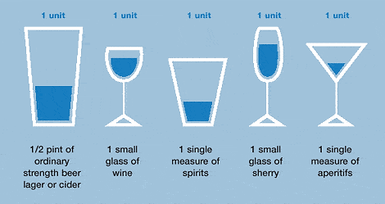

Half pint of regular beer, cider or lager | 1 very small glass of wine | 1 single measure of spirit | 1 small glass of sherry | 1 single measure aperitif

9.9 | Please answer all of the question below. If your answers are underlined, it indicates that you are at incrased risk of harmful drinking. If you would like to discuss your drinking further, please book an appointment with a GP or Nurse.

How often have you had 8 (men)/6 (women) or more units on a single occasion? | Never  ☐ | Less than monthly  ☐ | Monthly  ☐ | Weekly  ☐ | Daily or almost daily  ☐
How often in the last year have you not been able to remember when drinking the night before? | Never  ☐ | Less than monthly  ☐ | Monthly  ☐ | Weekly  ☐ | Daily or almost daily  ☐
How often in the last year have you failed to do what was expected of you because of drinking? | Never  ☐ | Less than monthly  ☐ | Monthly  ☐ | Weekly  ☐ | Daily or almost daily  ☐
Has a relative or friend, doctor or other health worker been concerned about your drinking or suggested that you cut down? | No  ☐ |  | Yes, but not in the last year  ☐ |  | Yes, during the last year  ☐

Sexual Health
Chlamydia and gonorrhoea: Southwark has a higher than average rate of these infections, self-testing kits are available at the practice. Please ask at reception for more information.
HIV and other blood borne viruses: Southwark has a higher than average rate of HIV and hepatitis; to get tested please ask at reception for details. Please note there is a local policy for routine HIV testing as part of standard blood tests.

Immunisations and vaccinations
9.10 | Please state any vaccinations you have previously had.
 | Covid-19 vaccination dose 1 | Date:
 | Covid-19 vaccination dose 2 | Date:

Screening
9.11 | Are you pregnant? | Yes ☐ No ☐
 | If so, have you had vaccinations for whooping cough and flu? | Yes ☐ No ☐
9.12 | For women aged 25-64: When was your last smear test/cervical screening? | Date:
9.13 | For women aged 50 -71: When was your last mamogram? | Date:
9.14 | For men aged 60-74: When was your last bowel screening? | Date:

NHS Health Check
If you are aged between 40 -75 years old and you are not known to have a pre-existing health condition (such as diabetes or heart disease) and are eligible for a free NHS health check in the last 5 years. If you do not have a pre-existing health condition, please book an appointment with a member of the nursing team.

- Prescriptions

For repeat prescriptions, we use the NHS app for smartphones, or Patient Access online. You can also visit your local pharmacy who will arrange to have your prescription delivered directly to them. Please note that all prescriptions will be sent electronically to your nominated pharmacy.
10.1 | Please name your preferred pharmacy for collection of your prescriptions/medication

- Patient Participation Group
Our PPGs are a mix of registered patients and practice staff who meet to discuss and make decisions about the organisation. It an opportunity for patients and service users to feed back about the services we offer.
11.1 | Would you like to join our patient participation group? | Yes ☐ No ☐

Thank you for your information. Your preferred practice will be in touch if any additional information is required.
Please email your completed form to nexus.recordsmanagement@nhs.net
If you are registering a child today, please use the form below.

Nexus Health Group child patient registration form
- To be completed by the person registering the child:
1.2 | Your name
1.3 | Your address
1.4 | Your telephone number
1.5 | Your email address
1.6 | What is your relationship to the child?
1.7 | Are you an existing Nexus Health Group patient? | Yes ☐ No ☐
Please select the practice you would like the child registered at:
Artesian Health Centre |  | ☐ | Dun Cow Surgery | ☐
Aylesbury Medical Centre |  | ☐ | Manor Place Surgery | ☐
Commercial Way Surgery |  | ☐ | Princess Street Practice | ☐
Decima Street Surgery |  | ☐ | Sir John Kirk Close Surgery | ☐
 |  |  | Surrey Docks Health Centre | ☐

- Personal details of the child:
13.1 | Last name
13.2 | First name(s)
13.3 | Date of birth
13.4 | Address of child
13.5 | Who does this child live with (e.g. mum, dad, others)?
13.6 | Does this child have a social worker? | Yes ☐ No ☐
 | If yes, please provide the contact details.
13.7 | Who is the emergency contact for the child?
13.8 | What is the name of your childs nursery or school?
Immunisations play a crucial role in keeping children healthy. We want to ensure your child is up to date with their immunisations according to the UK schedule. Please can you bring in your child’s red book or immunisation record and give to the reception team.

13.9 | Please tell us any significant medical history of this child:
13.10 | Please tell us any medication this child is currently taking:
13.11 | Please tell us here about any allergies this child has:

- Family history:

Family history
Please record any significant family history of close relatives with medical problems in the table below and confirm which relative e.g. mother, father, brother, sister, aunt, uncle, grandparent.
Is the following in your family? |  | Which family member has this illness?
Asthma | Yes ☐ No ☐
Chronic Respiratory disease | Yes ☐ No ☐
Ischaemic Heart Disease (IHD) | Yes ☐ No ☐
Hypercholesterolemia | Yes ☐ No ☐
Diabetes Mellitus Type 1 | Yes ☐ No ☐
Stroke | Yes ☐ No ☐

- Prescriptions:

Prescriptions
Your child will be registered for the electronic prescription service (EPS). All prescriptions will be sent electronically to the pharmacy for collection.
Do you consent to your child being registered for EPS?
Your preferred pharmacy for your child’s prescriptions

- Communicating with you about this child:
Sharing the child’s health record
Do you consent to Nexus sharing this child’s health record with other organisations that care for this child? | Yes ☐ No ☐
Summary Care record:
A summary care record (SCR) is an electronic summary of key health information. It will hold limited essential information derived initially from your GP record.This will include medication, adverse reactions and allergies. If you wish to know more regarding the system and the benefits, please visit www.nhscarerecords.nhs.uk or call 0845 603 8510.
Would you like to opt your child into the SCR? | Yes ☐ No ☐

Can we contact you via text message about this child? | Yes ☐ No ☐
Can we contact you via email about this child? | Yes ☐ No ☐

Is there anything else you would like us to know about the child you are registering?

Thank you.

